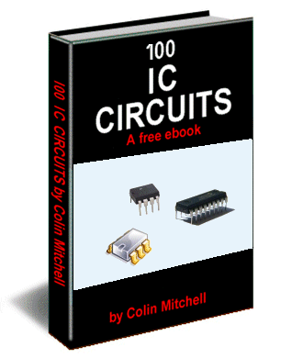

For our other three free eBooks,
Go to: 1 - 100 Transistor Circuits
Go to: 101 - 200 Transistor Circuits
Go to: 50 - 555 Circuits
12 IC CIRCUITS as of 19-2-2010

See TALKING ELECTRONICS WEBSITE
email Colin Mitchell: talking@tpg.com.au
INTRODUCTION
This is the third part of our Circuits e-book series. It contains a further 100 circuits. This time we have concentrated on circuits containing one or more IC's.
It's amazing what you can do with transistors but when Integrated Circuits came along, the whole field of electronics exploded.
IC's can handle both analogue as well as digital signals but before their arrival, nearly all circuits were analogue or very simple "digital" switching circuits.
Let's explain what we mean.
The word analogue is a waveform or signal that is changing (increasing and decreasing) at a constant or non constant rate. Examples are voice, music, tones, sounds and frequencies. Equipment such as radios, TV's and amplifiers process analogue signals.
Then digital came along.
Digital is similar to a switch turning something on and off.
The advantage of digital is two-fold.
Firstly it is a very reliable and accurate way to send a signal. The signal is either HIGH or LOW (ON or OFF). It cannot be half-on or one quarter-off.
And secondly, a circuit that is ON, consumes the least amount of energy in the controlling device. In other words, a transistor that is fully turned ON and driving a motor, dissipates the least amount of heat. If it is slightly turned ON or nearly fully turned ON, it gets very hot.
And obviously a transistor that is not turned on at all will consume no energy.
A transistor that turns ON fully and OFF fully is called a SWITCH.
When two transistors are cross-coupled in the form of a flip flop, any pulses entering the circuit cause it to flip and flop and the output goes HIGH on every second pulse. This means the circuit halves the input pulses and is the basis of counting or dividing. It is also the basis of a "Memory Cell" as will will hold a piece of information.
Digital circuits also introduce the concept of two inputs creating a HIGH output when both are HIGH and variations of this.
This is called "logic" and introduces terms such as "Boolean algebra" (Boolean logic) and "gates."
Integrated Circuits started with a few transistors in each "chip" and increased to mini or micro computers in a single chip. These chips are called Microcontrollers and a single chip with a few surrounding components can be programmed to play games, monitor heart-rate and do all sorts of amazing things. Because they can process information at high speed, the end result can appear to have intelligence and this is where we are heading: AI (Artificial Intelligence).
In this IC Circuits ebook, we have presented about 100 interesting circuits using Integrated Circuits.
In most cases the IC will contain 10 - 100 transistors, cost less than the individual components and take up much less board-space. They also save a lot of circuit designing and quite often consume less current than discrete components or the components they replace.
In all, they are a fantastic way to get something working with the least componentry.
A list of of some of the most common Integrated Circuits (Chips) is provided at the end of this book to help you identify the pins and show you what is inside the chip.
Some of the circuits are available from Talking Electronics as a kit, but others will have to be purchased as individual components from your local electronics store. Electronics is such an enormous field that we cannot provide kits for everything. But if you have a query about one of the circuits, you can contact me.
Colin Mitchell
TALKING ELECTRONICS.
talking@tpg.com.au
To save space we have not provided lengthy explanations of how the circuits work. This has already been covered in TALKING ELECTRONICS Basic Electronics Course, and can be obtained on a CD for $10.00 (posted to anywhere in the world) See Talking Electronics website for more details: http://www.talkingelectronics.com

MORE INTRO
We have said this before abut we will say it again: There are two ways to learn electronics.
One is to go to school and study theory for 4 years and come out with all the theoretical knowledge in the world but very little practical experience. The other is to "learn on the job."
I am not saying one approach is better than the other but most electronics enthusiasts are not "book worms" and many have been dissuaded from entering electronics due to the complex mathematics surrounding University-type courses.
Our method is to get around this by advocating designing, building, constructions and even more assembly with lots of experimenting and when you get stuck with a mathematical problem, get some advice or read about it via the thousands of free test books on the web.
Anyone can succeed in this field by applying themselves to constructing projects. You actually learn 10 times faster by doing it yourself and we have had lots of examples of designs from students in the early stages of their career.
And don't think the experts get it right the first time. Look at all the recalled electronics equipment from the early days.
The most amazing inventions have come from almost "newcomers" as evidenced by looking through the "New Inventions" website.
All you have to do is see a path for your ideas and have a goal that you can add your ideas to the "Word of Invention" and you succeed.
Nothing succeeds like success. And if you have a flair for designing things, electronics will provide you a comfortable living for the rest of your life.
The market is very narrow but new designs are coming along all the time and new devices are constantly being invented and more are always needed.
Once you get past this eBook of "Chips" you will want to investigate microcontrollers and this is when your options will explode.
You will be able to carry out tasks you never thought possible, with a chip as small as 8 pins and a few hundred lines of code.
In two weeks you can start to understand the programming code for a microcontroller and perform simple tasks such as flashing a LED and produce sounds and outputs via the press of a button.
All these things are covered on Talking Electronics website and you don't have to buy any books or publications. Everything is available on the web and it is instantly accessible. That's the beauty of the web.
Don't think things are greener on the other side of the fence, by buying a text book. They aren't. Everything you need is on the web AT NO COST.
The only thing you have to do is build things. If you have any technical problem at all, simply email Colin Mitchell and any question will be answered. Nothing could be simpler and this way we guarantee you SUCCESS. Hundreds of readers have already emailed and after 5 or more emails, their circuit works. That's the way we work. One thing at a time and eventually the fault is found.
If you think a circuit will work the first time it is turned on, you are fooling yourself.
All circuits need corrections and improvements and that's what makes a good electronics person. Don't give up. How do you think all the circuits in these eBooks were designed? Some were copied and some were designed from scratch but all had to be built and adjusted slightly to make sure they worked perfectly.
I don't care if you use bread-board, copper strips, matrix board or solder the components in the air as a "bird's nest." You only learn when the circuit gets turned on and WORKS!
In fact the rougher you build something, the more you will guarantee it will work when built on a printed circuit board.
However, high-frequency circuits (such as 100MHz FM Bugs) do not like open layouts and you have to keep the construction as tight as possible to get them to operate reliably.
In most other cases, the layout is not critical.
If you just follow these ideas, you will succeed.
A few of the basics are also provided in this eBook, the first is transistor outlines:
TRANSISTORS
Most of the transistors used in our circuits are BC 547 and BC 557. These are classified as "universal" or "common" NPN and PNP types with a voltage rating of about 25v, 100mA collector current and a gain of about 100.
You can use almost any type of transistor to replace them and here is a list of the equivalents and pinouts:
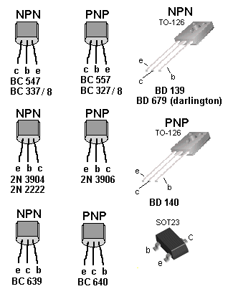

CONTENTS
Activate after 3 rings  AND Gate  Any Capacitor Value  Any Resistor Value  BFO Metal Locator  Flash LEDs for 20 Seconds  Gates  Intercom  Knock Knock Doorbell  LED Zeppelin - a game of skill  Logic Gates  Metal Detector - BFO | Phone Charger  Phone ring detector  Police Lights  Resistor Colour Code  Simple BFO Metal Locator  10 Second Alarm  1.5v to 5v Phone Charger  555

RESISTOR COLOUR CODE
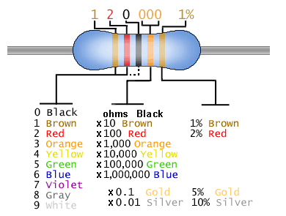
See resistors from 0.22ohm to 22M in full colour at end of book and another resistor table
THE 555
The 555 is everywhere. It is possibly the most-frequency used chip and is easy to use.
But if you want to use it in a "one-shot" or similar circuit, you need to know how the chip will "sit."
For this you need to know about the UPPER THRESHOLD (pin 6) and LOWER THRESHOLD (pin 2):
The 555 is fully covered in a 3 page article on Talking Electronics website (see left index: 555 P1 P2 P3)
Here is the pin identification for each pin:
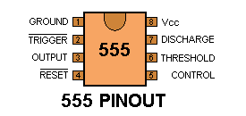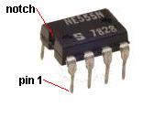
When drawing a circuit diagram, always draw the 555 as a building block with the pins in the following locations. This will help you instantly recognise the function of each pin:
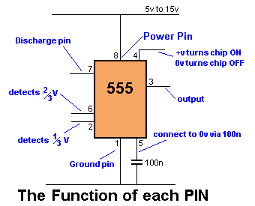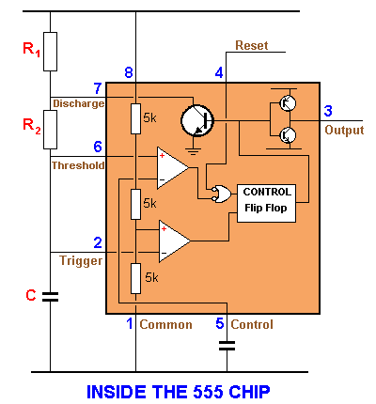
Note: Pin 7 is "in phase" with output Pin 3 (both are low at the same time).
Pin 7 "shorts" to 0v via the transistor. It is pulled HIGH via R1.
Maximum supply voltage 16v - 18v
Current consumption approx 10mA
Output Current sink @5v = 5 - 50mA @15v = 50mA
Output Current source @5v = 100mA @15v = 200mA
Maximum operating frequency 300kHz - 500kHz
Faults with Chip:
Consumes about 10mA when sitting in circuit
Output voltage up to 2.5v less than rail voltage
Output is 0.5v to 1.5v above ground
Sources up to 200mA but sinks only 50mA
HOW TO USE THE 555
There are many ways to use the 55.
(a) Astable Multivibrator - constantly oscillates
(b) Monostable - changes state only once per trigger pulse - also called a ONE SHOT
(c) Voltage Controlled Oscillator
ASTABLE MULTIVIBRATOR
The output frequency of a 555 can be worked out from the following graph:
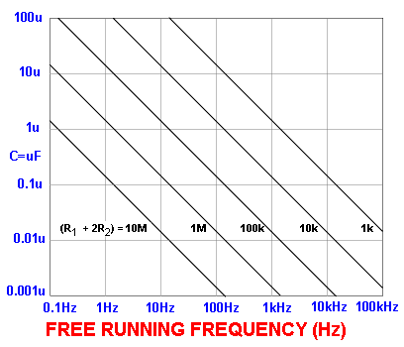
The graph applies to the following Astable circuit:
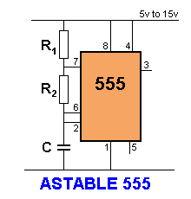 | The capacitor C charges via R1 and R2 and when the voltage on the capacitor reaches 2/3 of the supply, pin 6 detects this and pin 7 connects to 0v. The capacitor discharges through R2 until its voltage is 1/3 of the supply and pin 2 detects this and turns off pin7 to repeat the cycle.  The top resistor is included to prevent pin 7 being damaged as it shorts to 0v when pin 6 detects 2/3 rail voltage.  Its resistance is small compared to R2 and does not come into the timing of the oscillator.
Using the graph:
Suppose R1 = 1k, R2 = 10k and C = 0.1 (100n).
Using the formula on the graph, the total resistance = 1 + 10 + 10 = 21k
The scales on the graph are logarithmic so that 21k is approximately near the "1" on the 10k. Draw a line parallel to the lines on the graph and where it crosses the 0.1u line, is the answer. The result is approx 900Hz.
Suppose R1 = 10k, R2 = 100k and C = 1u
Using the formula on the graph, the total resistance = 10 + 100 + 100 = 210k
The scales on the graph are logarithmic so that 210k is approximately near the first "0" on the 100k. Draw a line parallel to the lines on the graph and where it crosses the 1u line, is the answer. The result is approx 9Hz.
The frequency of an astable circuit can also be worked out from the following formula:
frequency = | 1.4
frequency = | (R₁ + 2R₂) × C

555 astable frequencies
C | R₁ = 1k  R₂ = 6k8 | R₁ = 10k  R₂ = 68k | R₁ = 100k  R₂ = 680k
0.001µ | 100kHz | 10kHz | 1kHz
0.01µ | 10kHz | 1kHz | 100Hz
0.1µ | 1kHz | 100Hz | 10Hz
1µ | 100Hz | 10Hz | 1Hz
10µ | 10Hz | 1Hz | 0.1Hz

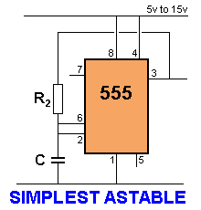 | The simplest Astable uses one resistor and one capacitor. Output pin 3 is used to charge and discharge the capacitor.

LOW FREQUENCY OSCILLATORS
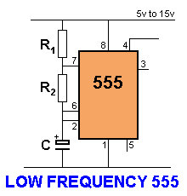 | If the capacitor is replaced with an electrolytic, the frequency of oscillation will reduce. When the frequency is less than 1Hz, the oscillator circuit is called a timer or "delay circuit." The 555 will produce delays as long as 30 minutes but with long delays, the timing is not accurate.

555 Delay Times:
C | R₁ = 100k  R₂ = 100k | R₁ = 470k  R₂ = 470k | R₁ = 1M  R₂ = 1M
10µ | 2.2sec | 10sec | 22sec
100µ | 22sec | 100sec | 220sec
470µ | 100sec | 500sec | 1000sec

555 ASTABLE OSCILLATORS
Here are circuits that operate from 300kHz to 30 minutes:
(300kHz is the absolute maximum as the 555 starts to malfunction with irregular bursts of pulses at this high frequency and 30 minutes is about the longest you can guarantee the cycle will repeat.)
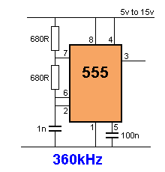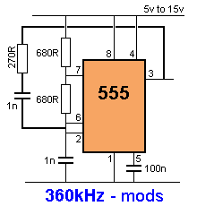
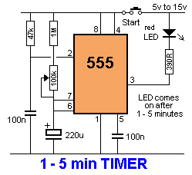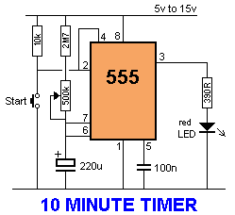
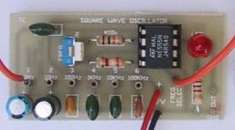
SQUARE WAVE OSCILLATOR
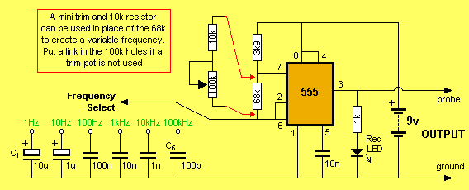
A square wave oscillator kit can be purchased from Talking Electronics for approx $10.00
See website: Square Wave Oscillator
It has adjustable (and settable) frequencies from 1Hz to 100kHz and is an ideal piece of Test Equipment.

555 Monostable or "one Shot"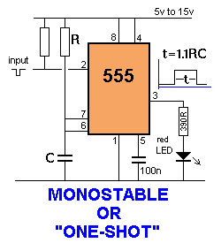
to Index
50 - 555 CIRCUITS
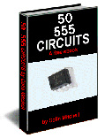
50 555 Circuits eBook can be accessed on the web or downloaded as a .doc or .pdf It has more than 50 very interesting 555 circuits and data on using a 555.
Table of Contents:
Active High Trigger  Active Low Trigger  Amplifier using 555  Astable Multivibrator  Bi-Coloured LED  Bi-Polar LED Driver  Car Tachometer  Clark Zapper  Clicks Uneven  Continuity Tester  Dark Detector  Driving A Bi-Coloured LED  Driving A Relay  Flashing Indicators  Flashing Railroad Lights  Flip Flop  Function of each 555 pin  Hee Haw Siren  High Frequency 555 Oscillator  How to use the 555  Increasing Output Current  Increasing Output Push-Pull Current  Inverter 12v to 240v  Inside the 555  Kitt Scanner  Knight Rider  Laser Ray Sound  Latch  LED Dimmer  Light Controlled Screamer Siren  Light Detector  Low Frequency 555 Oscillator  Machine Gun  Memory Cell  Metal Detector  Monostable 555  Morse Keyer  Mosquito Repellent  Motor PWM  Multivibrator - Astable  Negative Voltage  Normally Closed Trigger | One-Shot 555  Organ  Police Siren  Pulse Extender  Pulser - 74c14  PWM Controller  Railroad Lights (flashing)  Rain Alarm  Replacing 556 with two 555's  Resistor Colour Codes  Screamer Siren - Light Controlled  Servo Tester  Simplest 555 Oscillator  Siren 100dB  Square Wave Oscillator  Stun Gun  Substituting a 555 - Part 1  Substituting a 555 - Part 2  Switch Debounce  Tachometer  Ticking Bomb  Tilt Switch  Touch Switch  Toy Organ  Transistor Tester  Trigger Timer - 74c14  Uneven Clicks  Using the 555  Voltage Doubler  Wailing Siren  Zapper (Dr Clark)  Zener Diode Tester  2 Minute Timer - 74c14  10 Minute Timer - 74c14  12v to 240v Inverter  100dB Siren  555 Amplifier  555 Kit of Components  555 Pinout  555 Mistakes (No-No's)  556 Dual Timer

to Index
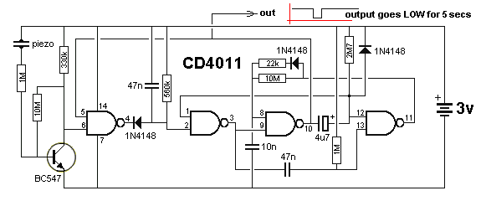
KNOCK KNOCK DOORBELL
This very clever circuit only produces an output when the piezo detects two taps. It can be used as a knock-knock doorbell. A PC board containing all components (soldered to the board) is available from talking electronics for $5.00 plus postage. Email HERE for details.
The circuit takes only a few microamp and when a tap is detected by the piezo, the waveform from the transistor produces a HIGH on pin 6 and the HIGH on pin 5 makes output pin 4 go low. This very quickly charges the 47n and it is discharged via the 560k to produce a brief pulse at pin 3.
The 47n is mainly to stop noise entering pin 2. Pin 1 is HIGH via the 2M7 and the LOW on pin 2 causes pin 3 to produce a HIGH pulse. The 47n is discharged via the internal diodes on pin 13 and when it goes LOW, pin 11 goes HIGH and charges the 10n via the 22k and diode.
This puts a HIGH on pin 8 for approx 0.7 seconds and when a second tap is detected, pin 9 sees a HIGH and pin 10 goes LOW. This put s a LOW on pin 12 and a HIGH on pin 8. The LOW on pin 12 goes to pin 1. A HIGH and LOW on the second NAND gate produces a HIGH on pin 3 and the third NAND gate has a HIGH on both inputs. This makes pin 10 LOW and the 4u7 starts to charge via the 2M7 resistor. After 5 seconds pin 12 sees a HIGH and pin 11 goes LOW. The 10n is discharged via the 10M and when pin 8 sees a LOW, pin 10 goes HIGH. The output sits HIGH and goes LOW for about 7 seconds.
to Index
LED ZEPPELIN
This circuit is a game of skill. See full article: LED Zeppelin. The kit is available from talking electronics for $15.50 plus postage. Email HERE for details.
The game consists of six LEDs and an indicator LED that flashes at a rate of about 2 cycles per second. A push button is the "Operations Control" and by carefully pushing the button in synchronisation with the flashing LED, the row of LEDs will gradually light up.
But the slightest mistake will immediately extinguish one, two or three LEDs. The aim of the game is to illuminate the 6 LEDs with the least number of pushes.
We have sold thousands of these kits. It's a great challenge.
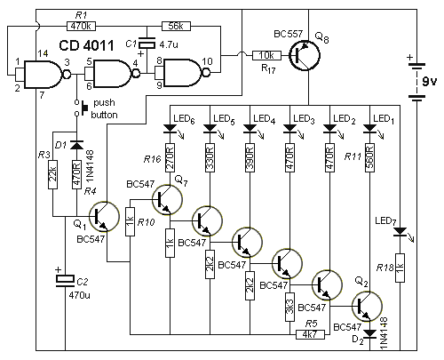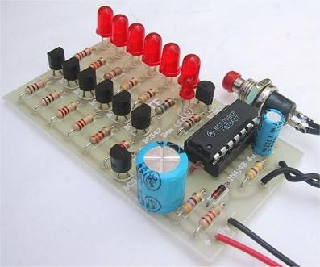
to Index
BFO METAL DETECTOR
The circuit shown must represent the limits of simplicity for a metal detector. It uses a single 4093 quad Schmitt NAND IC and a search coil -- and of course a switch and batteries. A lead from IC1d pin 11 needs to be attached to a MW radio aerial, or should be wrapped around the radio. If the radio has a BFO switch, switch this ON.
Since an inductor resists rapid changes in voltage (called reactance), any change in the logic level at IC1c pin 10 is delayed during transfer back to input pins 1 and 2. This is further delayed through propagation delays within the 4093 IC. This sets up a rapid oscillation (about 2 MHz), which is picked up by a MW radio. Any change to the inductance of L1 (through the presence of metal) brings about a change to the oscillator frequency. Although 2 MHz is out of range of the Medium Waves, a MW radio will clearly pick up harmonics of this frequency.
The winding of the coil is by no means critical, and a great deal of latitude is permissible. The prototype used 50 turns of 22 awg/30 swg (0.315 mm) enamelled copper wire, wound on a 4.7"/120 mm former. This was then wrapped in insulation tape. The coil then requires a Faraday shield, which is connected to 0V. A Faraday shield is a wrapping of tin foil around the coil, leaving a small gap so that the foil does not complete the entire circumference of the coil. The Faraday shield is again wrapped in insulation tape. A connection may be made to the Faraday shield by wrapping a bare piece of stiff wire around it before adding the tape. Ideally, the search coil will be wired to the circuit by means of twin-core or figure-8 microphone cable, with the screen being wired to the Faraday shield.
The metal detector is set up by tuning the MW radio to pick up a whistle (a harmonic of 2 MHz). Note that not every such harmonic works best, and the most suitable one needs to be found. The presence of metal will then clearly change the tone of the whistle. The metal detector has excellent stability, and it should detect a large coin at 80 to 90 mm, which for a BFO detector is relatively good. It will also discriminate between ferrous and non-ferrous metals through a rise or fall in tone.
Copyright Rev. Thomas Scarborough
The author may be contacted at scarboro@iafrica.com
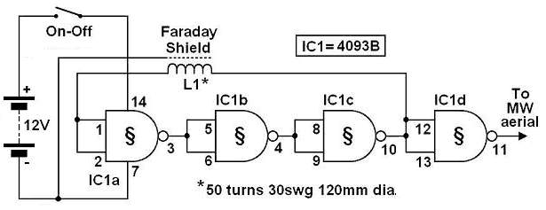
to Index
SIMPLE BFO METAL LOCATOR
This circuit uses a single coil and nine components to make a particularly sensitive low-cost metal locator. It works on the principle of a beat frequency oscillator (BFO).
The circuit incorporates two oscillators, both operating at about 40kHz. The first, IC1a, is a standard CMOS oscillator with its frequency adjustable via VR1.
The frequency of the second, IC1b, is highly dependent on the inductance of coil L1, so that its frequency shifts in the presence of metal. L1 is 70 turns of 0.315mm enamelled copper wire wound on a 120mm diameter former. The Faraday shield is made of aluminum foil, which is wound around all but about 10mm of the coil and connected to pin 4 of IC1b.
The two oscillator signals are mixed through IC1c, to create a beat note. IC1d and IC1c drive the piezo sounder in push-pull fashion, thereby boosting the output.
Unlike many other metal locators of its kind, this locator is particularly easy to tune. Around the midpoint setting of VR1, there will be a loud beat frequency with a null point in the middle. The locator needs to be tuned to a low frequency beat note to one or the other side of this null point.
Depending on which side is chosen, it will be sensitive to either ferrous or non-ferrous metals. Besides detecting objects under the ground, the circuit could serve well as a pipe locator.
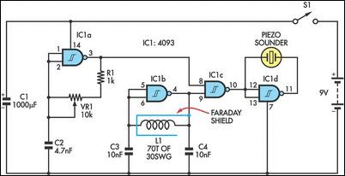
to Index
1.5v to 5v PHONE CHARGER
Look at the photos. The circuit is simple. It looks like two surface-mount transistors, an inductor, diode, capacitor, resistor and LED.
But you will be mistaken.
One of the "transistors" is a microcontroller and the other is a FET.
The microcontroller is powered from the output (5v) of the circuit and when it detects no-load, it shuts down to a very low level of operation.
When the 1v5 batter is connected, the micro starts up at less than 1v5 due to the Schottkey diode and charges the 1u capacitor by driving the FET and using the flyback effect of the inductor to produce a high voltage. When the output voltage is 5v, the microcontroller turns off and the only load on the 1u is the microcontroller. When the voltage drops across this capacitor, the microcontroller turns on in bursts to keep the 1u charged to exactly 5v. The charger was purchased for $3.00 so it is cheaper to buy one and use it in your own project. It also comes with 4 adapter leads!
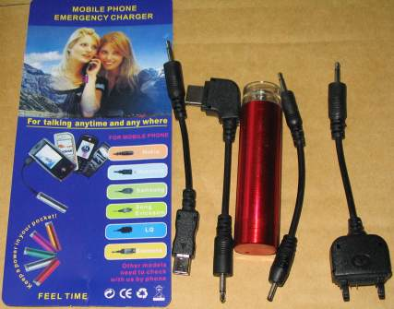
The AA case and 4 adapter leads - cost: $3.00!!
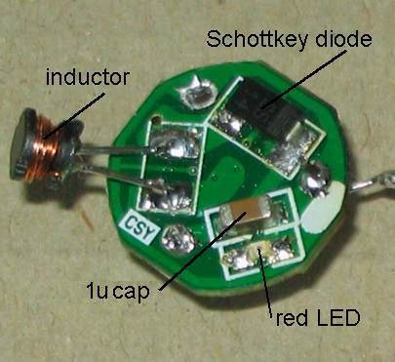
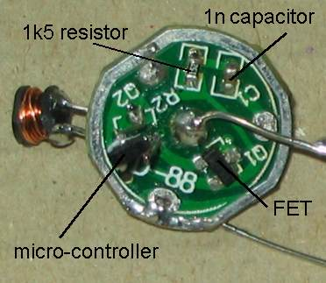
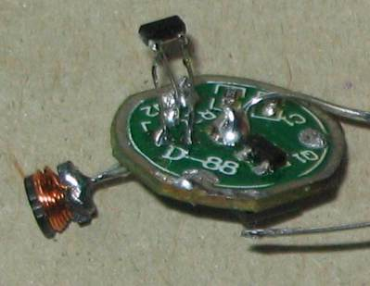
The micro has been placed on extension wires to test its operation.

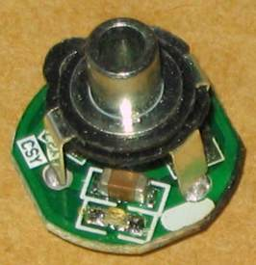  The LED and 1u capacitor can be clearly seen in this photo. | 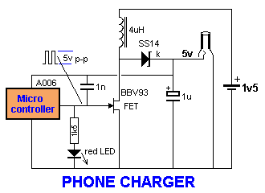  Sometimes it is better to use something that is already available, rather than trying to re-invent the wheel. This is certainly the case with this project. You could not buy the components for the cost of the complete phone charger and extension leads.  The circuit will deliver 70mA at 5v and if a higher current is drawn, the voltage drops slightly.  These chargers were originally priced at $30.00 !!

to Index
10 SECOND ALARM
This circuit is activated for 10 seconds via the first two gates. They form a LATCH to keep the oscillator (made up of the next two gates) in operation, to drive the speaker.
The circuit consumes a few microamps in quiescent mode and the TOUCH PLATES can be any type of foil on a door knob or item that is required to be protected. The 10u sits in an uncharged condition and when the plates are touched, the voltage on pin 1 drops below 50% rail and makes pin 3 HIGH. This pulls pins 5 and 6 HIGH and makes pin 4 LOW. This keeps pin 3 HIGH, no matter if a HIGH or LOW is on pin1. This turns on the oscillator and the 10u starts to charge via the 100k resistor. After about 10 seconds, the voltage on pins 5 and 6 drops to below 50% rail voltage and pin 4 goes HIGH. If the TOUCH PLATES are not touched, pin 3 will go LOW and the oscillator will stop. 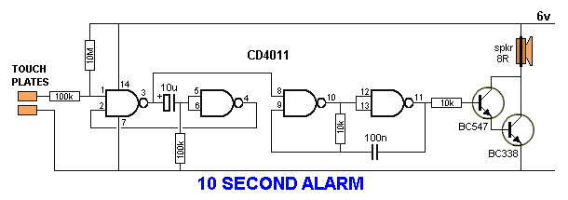
to Index
USING A VOLTAGE REGULATOR
This circuit shows how to use a voltage regulator to convert a 24v supply to 12v for a 555 chip. Note: the pins on the regulator (commonly called a 3-terminal regulator) are: IN, COMMON, OUT and these must match-up with: In, Common, Out on the circuit diagram.
If the current requirement is less than 500mA, a 100R "safety resistor" can be placed on the 24v rail to prevent spikes damaging the regulator.
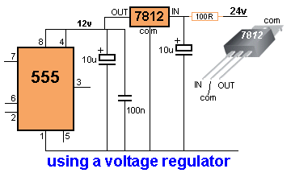
to Index
POLICE LIGHTS
These three circuits flash the left LEDs 3 times then the right LEDs 3 times, then repeats. The only difference is the choice of chips.
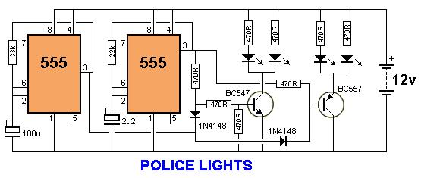
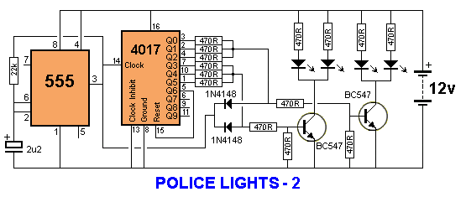
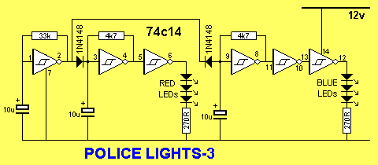
to Index
FLASH LEDS FOR 20 SECONDS
This circuit comes from a request from a reader. It flashes a LED for 20 seconds after a switch is pressed. The values will need to be adjusted to get the required flash-rate and timing. 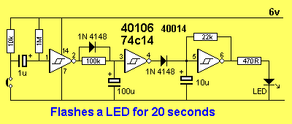
to Index
INTERCOM
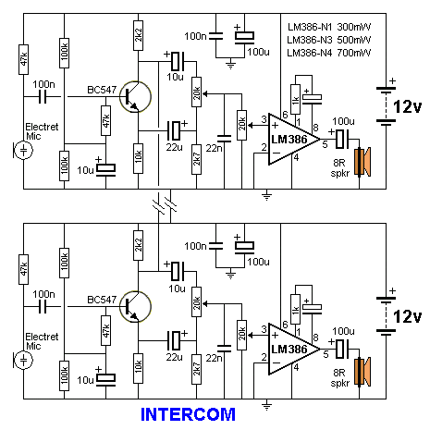
This circuit uses a single transistor and LM386 amplifier IC to produce an intercom that allows hands-free operation.
As both microphones and loudspeakers are always connected, the circuit is designed to avoid feedback - known as the "Larsen effect".
The microphone amplifier transistor is 180° phase-shifted and one of the audio outputs is taken at the collector and its in-phase output taken at the emitter. These are mixed by the 10u, 22u, 20k pot and 2k7 so that the two signals almost cancel out. In this way, the loudspeaker will reproduce a very faint copy of the signals picked-up by the microphone.
At the same time, as both collectors of the two intercom units are tied together, the 180° phase-shifted signal will pass to the audio amplifier of the second unit without attenuation, so it will be loudly reproduced by its loudspeaker.
The same operation will occur when speaking into the microphone of the second unit. When the 20k pot is set correctly, almost no output will be heard from the loudspeaker but a loud and clear reproduction will be heard at the output of the other unit. The second 20k pot adjusts the volume.
to Index
ACTIVATE VIA 3 PHONE RINGS
This circuit connects to a phone. When the phone rings for 3 or 4 rings, the relay is activated for about 1 minute.
The circuit takes less than 100uA when in quiescent state and when the phone rings, the ring voltage is passed to pin 1 via the 100k and 100n capacitor. This causes pin 2 to go HIGH and charge two 100u electrolytics. The lower 100u charges in 7 seconds and the upper charges in 12 seconds. If the phone rings for only 3 rings, pin 4 goes LOW and charges the third 100u via a 47k resistor. After a further 7 seconds, pin 10 goes HIGH. If the phone stops ringing after 3 rings, the lower 100u starts to discharge via the 470k and after about 40 seconds pin 4 goes HIGH. The third 100u now starts to discharge via the 470k across it and the relay turns off.
If the phone rings for more than 5 rings, the top 100u will charge and pin 6 will go LOW and cause pin 8 to go HIGH and prevent pin 11 going LOW via the gating diode.
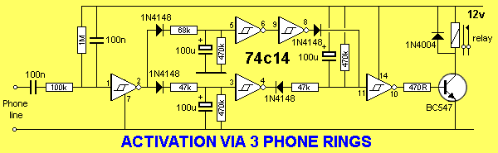

to Index
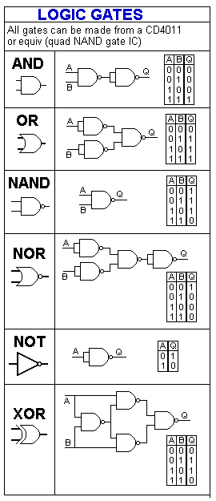
LOGIC GATES
It's very handy to remember that all the logic gates can be made from a Quad NAND gate such as CD4011.
to Index
Circuit Symbols
The list below covers almost every symbol you will find on an electronic circuit diagram. It allows you to identify a symbol and also draw circuits. It is a handy reference and has some symbols that have never had a symbol before, such as a Flashing LED and electroluminescence panel.
Once you have identified a symbol on a diagram you will need to refer to specification sheets to identify each lead on the actual component.
The symbol does not identify the actual pins on the device. It only shows the component in the circuit and how it is wired to the other components, such as input line, output, drive lines etc. You cannot relate the shape or size of the symbol with the component you have in your hand or on the circuit-board.
Sometimes a component is drawn with each pin in the same place as on the chip etc. But this is rarely the case.
Most often there is no relationship between the position of the lines on the circuit and the pins on the component.
That’s what makes reading a circuit so complex.
This is very important to remember with transistors, voltage regulators, chips and so many other components as the position of the pins on the symbol are not in the same places as the pins or leads on the component and sometimes the pins have different functions according to the manufacturer. Sometimes the pin numbering is different according to the component, such as positive and negative regulators.
You must to refer to the manufacturer’s specification sheet to identify each pin, to be sure you have identified them correctly.
Colin Mitchell

CIRCUIT SYMBOLS
Some additional symbols have been added to the following list. See Circuit Symbols on the index of
Talking Electronics.com
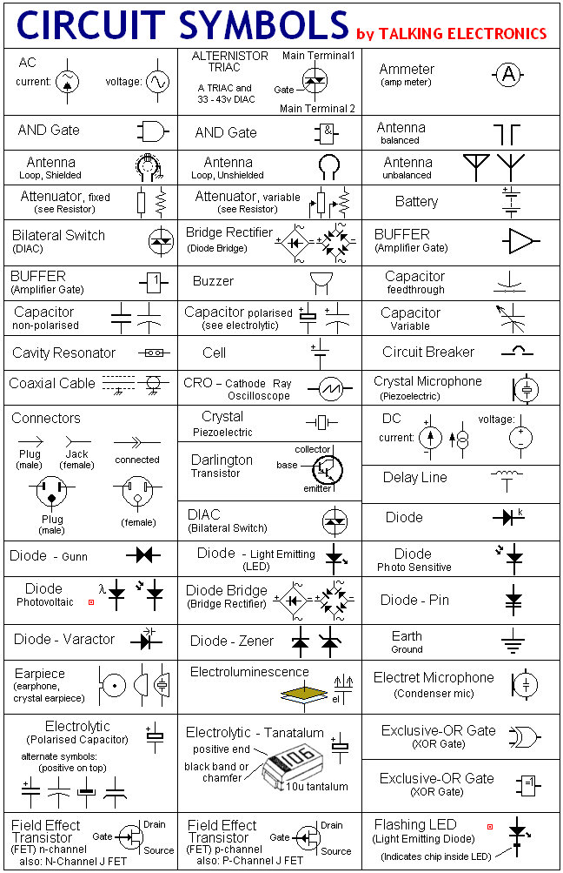
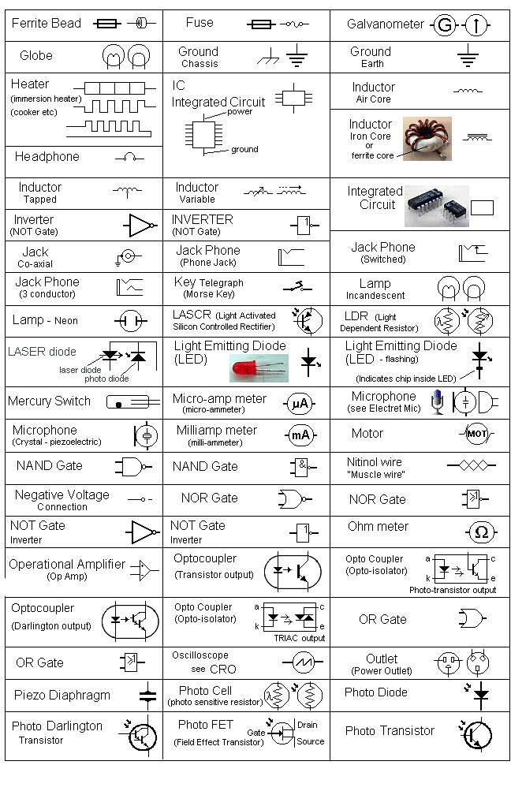
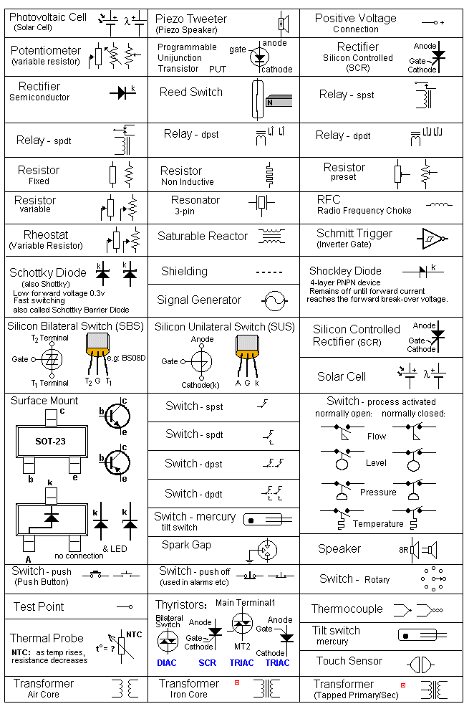
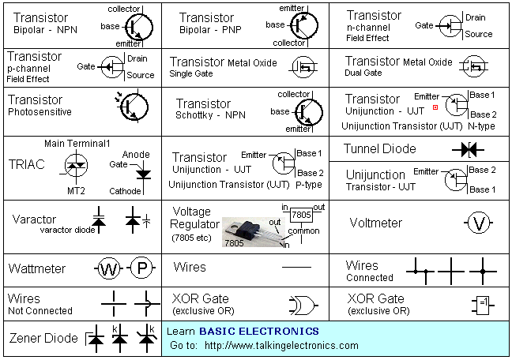
to Index
IC PINOUTS
The following list covers just a few of the IC's on the market and these are the "simple" or "basic" or "digital" or "op-amp" IC's suitable for experimenting.
When designing a circuit around an IC, you have to remember two things:
1. Is the IC still available? and
2. Can the circuit be designed around a microcontroller?
Sometimes a circuit using say 3 or 4 IC's can be re-designed around an 8-pin or 16-pin microcontroller and the program can be be kept from prying eyes due to a feature called "code protection." A microcontroller project is more up-to-date, can be cheaper and can be re-programmed to alter the features.
This will be covered in the next eBook. It is worth remembering - as it is the way of the future.
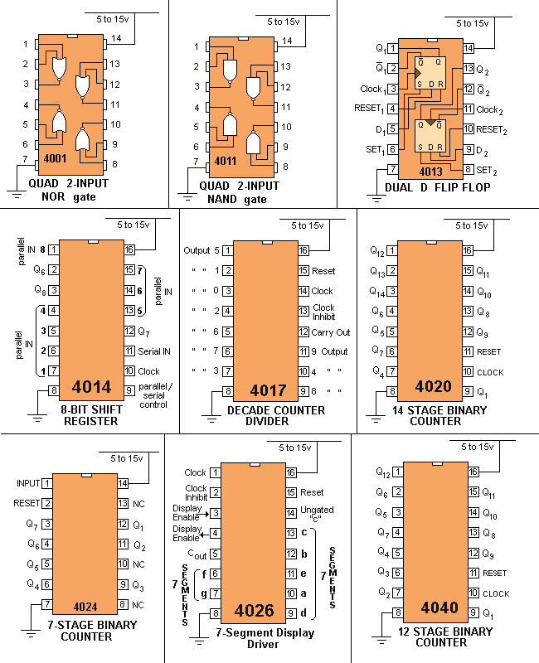
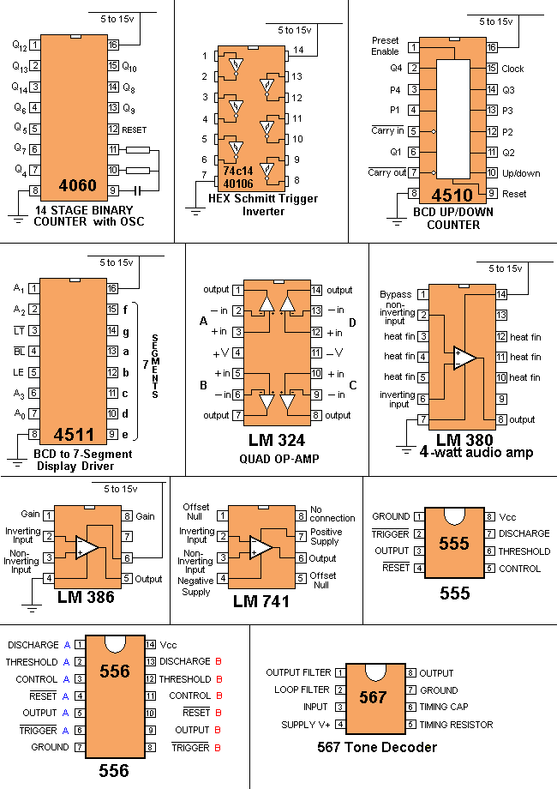
to Index
All the resistor colours:
This is called the "normal" or "3 colour-band" (5%) range. If you want the 4 colour-band (1%) series, refer to
Talking Electronics website and click: Resistors 1% on the left index. Or you can use the table below.
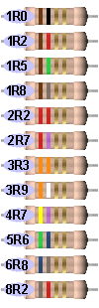 | 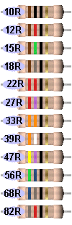 | 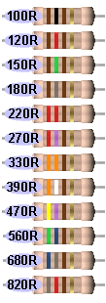 | 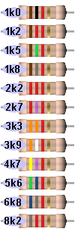
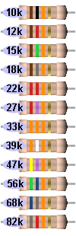 | 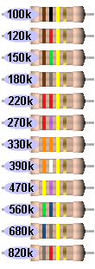 | 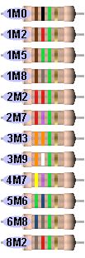 | 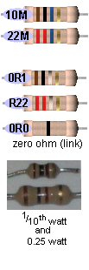
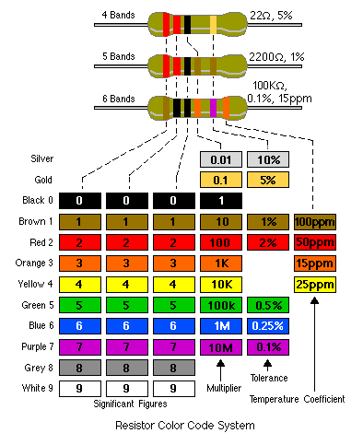
to Index
MAKE ANY RESISTOR VALUE:
If you don't have the exact resistor value for a project, don't worry. Most circuits will work with a value slightly higher or lower.
But if you want a particular value and it is not available, here is a chart.
Use 2 resistors in series or parallel as shown:
Required  Value | R1 | Series/  Parallel | R2 | Actual  value:
10 | 4R7 | S | 4R7 | 9R4
12 | 10 | S | 2R2 | 12R2
15 | 22 | P | 47 | 14R9
18 | 22 | P | 100 | 18R
22 | 10 | S | 12 | 22
27 | 22 | S | 4R7 | 26R7
33 | 22 | S | 10 | 32R
39 | 220 | P | 47 | 38R7
47 | 22 | S | 27 | 49
56 | 47 | S | 10 | 57
68 | 33 | P | 33 | 66
82 | 27 | P | 56 | 83
There are other ways to combine 2 resistors in parallel or series to get a particular value. The examples above are just one way.
4R7 = 4.7 ohms
to Index
MAKE ANY CAPACITOR VALUE:
If you don't have the exact capacitor value for a project, don't worry. Most circuits will work with a value slightly higher or lower.
But if you want a particular value and it is not available, here is a chart.
Use 2 capacitors in series or parallel as shown:
Required  Value | C1 | Series/  Parallel | C2 | Actual  value:
10 | 4.7 | P | 4.7 | 9.4
12 | 10 | P | 2.2 | 12.2
15 | 22 | S | 47 | 14.9
18 | 22 | S | 100 | 18
22 | 10 | P | 12 | 22
27 | 22 | P | 4.7 | 26.7
33 | 22 | P | 10 | 32
39 | 220 | S | 47 | 38.7
47 | 22 | P | 27 | 49
56 | 47 | P | 10 | 57
68 | 33 | S | 33 | 66
82 | 27 | S | 56 | 83
The value "10" in the chart above can be 10p, 10n or 10u. The chart works for all decades (values).

